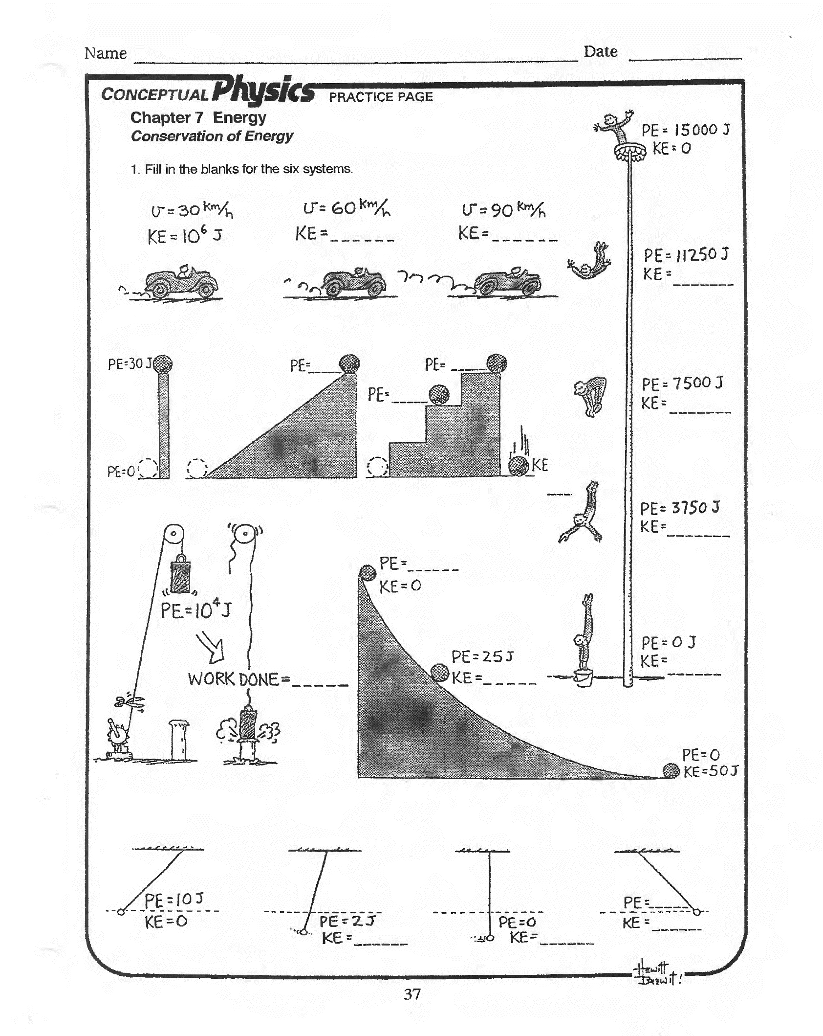

h = ______

m = 1 kg

h = _____

v = _____

h = 20 m

m = _____

1,000,000 J