Measurement Review Name_______

Angles & Sides
Determine the angles (θ) and side lengths (a) shown below without a ruler or protractor…
a = ____
53º
4 m
5 m
θ = ___
a = ____
θ = _______
6 m
125º

34º
θ = ____
9 m

Slope and Area
Determine the slope of the lines shown here.
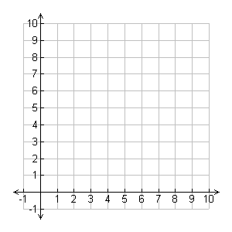
time
(s)
time
(s)
velocity
(m/s)
distance
(m)

ALGEBRA
Solve each of these equations for the variable given…

v = d / t

d =

t =

Graphing:

Graph the following data:

Time Distance
1 s 15 m
2 s 12 m
4 s 6 m
7 s 0 m

Find the slope of the line (include units)

Find the area between the line and the x-axis

