Pendulum Practice Problems
Simple and Physical Pendulums

- On a flat surface in Toledo, Ohio, a simple pendulum of length 0.58 m and mass 0.34 kg is pulled back an angle of 45° and released.
  - Determine the theoretical period of the pendulum.
  - When the period is measured (with a photogate, for 20 oscillations) it is found that the experimental period is 5 percent higher than expected. Repeated measurements consistently give similar values. What is the most likely explanation for this systematic error?
  - What would be the period of this pendulum if it was in a free-fall environment? Explain.

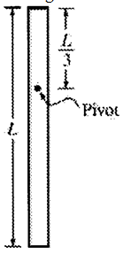
- A uniform rod of mass M and length L is attached to a pivot of negligible friction as shown above. The pivot is located at a distance L/3 from the left end of the rod. Express all answers in terms of the given quantities and fundamental constants.
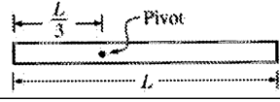
  - Calculate the rotational inertia of the rod about the pivot.
  - The rod is then released from rest from the horizontal position shown above. Calculate the linear speed of the bottom end of the rod when the rod passes through the vertical.
  - The rod is brought to rest in the vertical position shown above and hangs freely. It is then displaced slightly from this position. Calculate the period of oscillation as it swings.

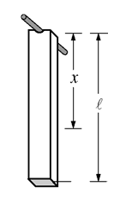
- You are given a long, thin, rectangular bar of known mass M and length L with a pivot attached to one end. The bar has a non-uniform mass density, and the center of mass is located a known distance x from the end with the pivot. You are to determine the rotational inertia I_{b} of the bar about the pivot by suspending the bar from the pivot, as shown above, and allowing it to swing. Express all algebraic answers in terms of I_{b} , the given quantities, and fundamental constants.
*Note: you are deriving the formula for the period of a physical pendulum
  - By applying the appropriate equation of motion to the bar, write the differential equation for the angle θ the bar makes with the vertical. (hint: write α as d²θ/dt²)
  - By applying the small-angle approximation to your differential equation, calculate the period of the bar’s motion.

Answers: (1-a) 1.53s, (b) based on small-angle approx. and 45deg is too big, (c) T = ∞ b/c the effects of gravity are not felt in free-fall; (2-a) ML²/9, (b) 2*sqrt(gL/3), (c) 2π*sqrt(2L/(3g)); (3-a) -mgxsinθ=I*d²θ/dt², (b) 2π*sqrt(I/(mgx))

Reference: Martha Lietz https://sites.google.com/a/d219.org/marlie/home

