Interpreting and Sketching Graphs of Motion
Understanding the motion of an object is often best understood and described by looking at or producing graphs of the position, velocity, and/or acceleration of the object as time progresses; x vs t, v vs t and a vs t graphs.
For Example
Description | Position vs time | Velocity vs time | Acceleration vs time
The position vs time graph of an object that starts at the origin and moves in the positive direction at a constant velocity would have the following set of graphs | 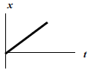 | The faster the object moves, the further away from the x axis the velocity will be | Velocity does not change so a = 0
An object starts to the right of the origin and moves at constant speed toward the origin and stops at the origin |  | 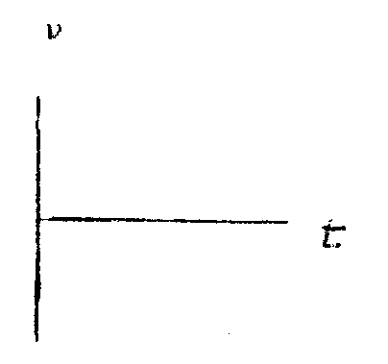
An object starts to the left of the origin and moves in the negative direction at a constant speed.
?? | 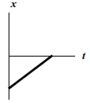
Object starts at origin and ??? |  | 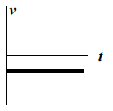

For motion that involves an object changing speed, or accelerating, graphs can also be used to understand and describe the motion.
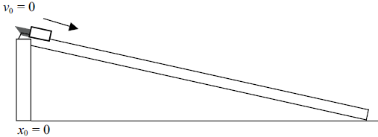

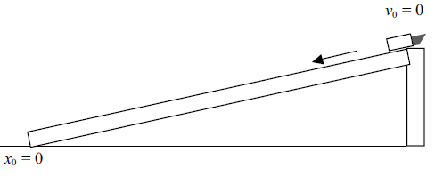
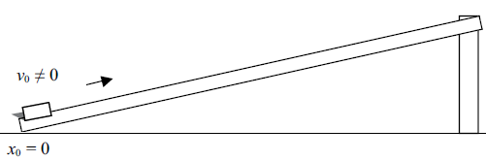
A cart is pushed up a ramp
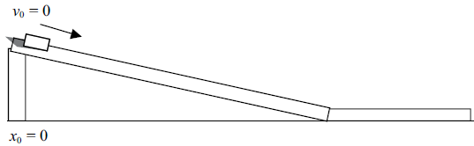
Cart goes down a ramp and onto a flat track

Cart starts at rest and rolls toward the origin and stops at the origin

(above situation)

