Circuits

All electric circuits have three main parts

1.

2.

3.

If ANY part of the circuit is open, the device will not __________

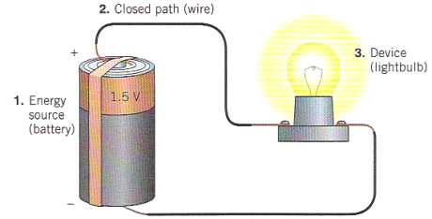

Voltage: a _______ that pushes the current through the circuit.

Voltage is sometimes called _______________ ___________

In a battery, a series of chemical reactions occur in which electrons are transferred from one terminal to another. There is a __________ _____________ (_____________) between these terminals.

Voltage is measured in ___________

Current: The actual ____________ that is flowing through the wires of the circuit (______________)

Current is defined as the rate at which _________ flows through a surface

Units are ___________

Resistance: ___________ that _________ the flow of current through the circuit

Resistance is provided by something that uses _________ in a circuit (a lightbulb)

Units of resistance are ____________

Resistance is based on three things. Think of it like a ________.....

The _________ the wire is, the more resistance it has.

The _________ the cross sectional area, the ______ resistance it has.

____________ is a property of the material the wire is made out of. (ρ)

Ex.

How much would resistance change if a wire was used with ½ the length and ½ the radius of another wire?

These three quantities are related using   
Ohm’s Law:

Power

Power is the ___________ of doing ____________. This is the same as ___________________

Energy is ______________, current is __________________, therefore power = ____________ * _____________

From the definition of power and Ohm’s Law we can come up with formulas for power.

Units are ________

Example: An electric heater emits 100 W when connected to a 120 V power line. What is the resistance in the heater?

Example: An electric fan has a resistance of 12 Ω and requires 0.75 A of current to function properly. What voltage is required to operate the fan?

Symbols you will see on circuit diagrams…….

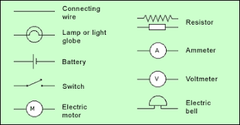

There are **two** ways that we can attach devices to a circuit.

**(1) Series:** only _____ path for current to flow. Therefore current flows through _______ device. If one device burns out, current __________ flow and no devices receive current.

Adding devices in series ____________ total resistance.

Ex. Draw a circuit with a battery connected to two resistors in series.

Since all resistors are part of the same loop, they each experience the ____________________ of current.

As current goes through the circuit, the charges must use energy to get through the resistors. All the resistors exist _________ the terminals of the battery which means they _________ the potential (voltage). As current moves through each resistor the voltage will drop.

Note: The terms “_______________” or “________________” may be used to mean total.

Example:

What is the total resistance?

What is the total current?

What is the current through each resistor?

What is the voltage drop across each resistor?

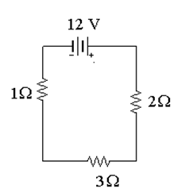

**(2) Parallel:** __________ pathways for current to flow. If one device burns out, the others will _______ receive current.

Adding devices in parallel ____________ total resistance.

Ex. Draw a circuit with a battery connected with two resistors in parallel.

In a parallel circuit, there are multiple loops. So the current ________ up among the loops with individual loops __________ to the total current.

Parallel circuits will all have some position where the current splits and comes back together. We call these ____________. The current going ____ to a junction will always equal the current going _____ of a junction. This is true or else electrons will build up at points, which is impossible because they repel each other.

Notice that the JUNCTIONS touch both the POSTIVE and NEGATIVE terminals of the battery. That means they have the ________ potential difference down EACH individual branch of the parallel circuit. This means that the individual voltages drops are ___________

Example:

What is the total resistance?

What is the total current?

What is the voltage across each resistor?

What is the current drop across each resistor?

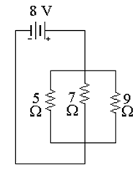

Let’s recap:

|  |  |  |
| --- | --- | --- |
| Value | Series | Parallel |
|  |  |  |
|  |  |  |
|  |  |  |

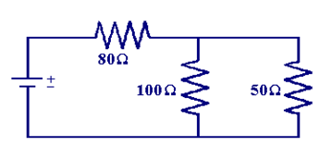Example: Compound (Complex) circuit

12 V

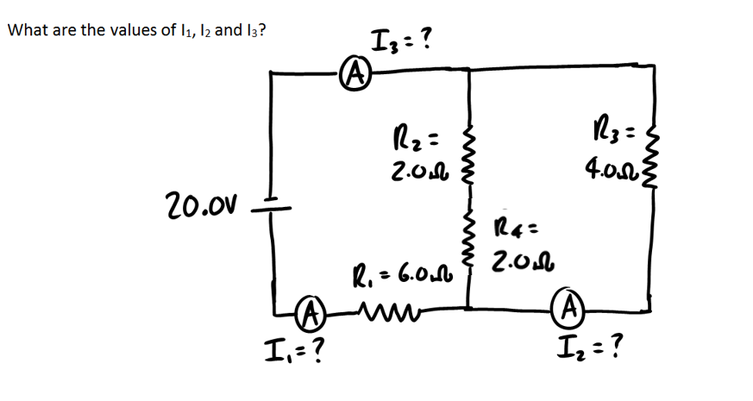

Measuring Voltage and Current

We measure the voltage in a circuit using a ___________________ and the current in a circuit using a ______________________.

You want them to ____________ without _____________ the circuit

We need to connect these two devices in different ways.

A ___________must be connected in ________________________. This is because a voltmeter measures the voltage drop ______________ a device. This way you can measure the change on either side of the device.

A voltmeter must have a very ________ resistance. That way when current comes to the junction, almost ______ of it will flow through the voltmeter and it will measure the voltage without affecting the circuit.

An ____________ must be connected in ___________________. This is because an ammeter measures the current ________________ a circuit.

An ammeter must have very **________** resistance, therefore when current flows through it, it will not be impeded and the ammeter can measure without affecting the circuit

Example:

Example

What would happen if a voltmeter was connected in series?

What would happen if an ammeter was connected in parallel?

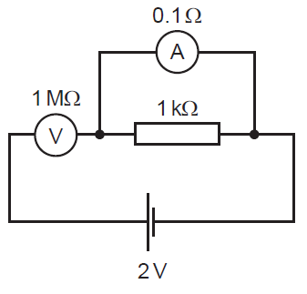

Example: Brightness of a lightbulb

A lightbulb is rated at 100W in the US, where the standard wall outlet is 120 V. If this bulb were plugged in in Europe, where the standard wall outlet is 240V, how much brighter would it be?