**Simple Harmonic Motion**

Simple Harmonic Motion: ______and ________ motion that is caused by a force that is directly proportional to the displacement. The displacement centers around an ____________ __________________. ______________ and __________________ move

in SHM

Period (T) – time for one complete ____________ (s)

Frequency (f) is the number of complete oscillations per _________ (Hertz)

Frequency and

period are

inverses, that

is _____________

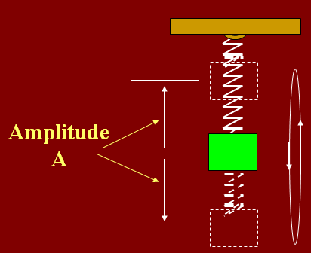

Ex: A suspended mass makes 30 complete oscillations in 15 s. What is the period and frequency of the motion?

Hooke’s Law

Sometimes it is written ___________

The __________ just means the force is trying to getting spring ______ to its __________ position

- A spring is a device that stores _______________ ________. (________)

- When a spring is stretched (or compressed), ________ is applied through a ________ which means _______ is done.

- The work done goes to the spring in the form of ______________________ .

- The spring force is a _____________ force which, in bringing the spring back to its rest point, does ___________

Ex. A spring is fixed along an inclined plane whose angle of incline is 30o. A 12 kg block is attached to the spring thereby stretching it 15 cm. Find the spring constant of this spring.

Ex: A load of 50 N attached to a spring hanging vertically stretches the spring 5.0 cm. The spring is now placed horizontally on a table and stretched 11.0 cm. What force is required to stretch the spring this amount?

Position graph of a spring

When you graph the motion of a spring, it is a ______ function

Springs (and waves) behave very similar to objects that move in __________.

If you trace out the position of an object on the outside of a circle, you get a ______ function (remember the unit circle??)

Ex: A 200 g mass is attached to a spring and executes simple harmonic motion with a period of 0.25 s. If the total energy of the system is 2.0 J, find the (a) force constant of the spring (b) the amplitude of the motion

Formula for period of a spring

Acceleration in SHM

Acceleration is in the direction of the ____________. (a is ___________ when x is ___________, and __________ when x is _________)

Acceleration is a ____________ at the end points and it is ________ at the midpoint of oscillation

Velocity in SHM

The __________ the spring moves determines the sign of ____________

It is ________ at the end points and a ___________ at the midpoint in either direction (+ or -).

Example: A 2-kg mass hangs at the end of a spring whose constant is k = 400 N/m. The mass is displaced a distance of 12 cm and released. What is the acceleration at the instant the displacement is x = +7 cm?

Example: A slingshot consists of a light leather cup, containing a stone, that is pulled back against 2 rubber bands. It takes a force of 30 N to stretch the bands 1.0 cm (a) What is the potential energy stored in the bands when a 50.0 g stone is placed in the cup and pulled back 0.20 m from the equilibrium position? (b) With what speed does it leave the slingshot?

Pendulums

Pendulums, like springs, oscillate back and forth exhibiting simple harmonic behavior

(if the __________ is small).

The restoring force is the force that brings the pendulum back to its equilibrium

The restoring force is __________________

Remember this formula only works if _____________

Ex: What must be the length of a simple pendulum for a clock which has a period of two seconds (tick-tock)?

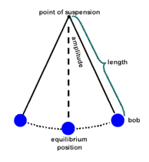

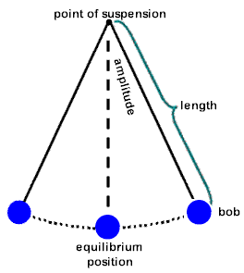

Ex: A visitor to a lighthouse wishes to determine the height of the tower. She ties a spool of thread to a small rock to make a simple pendulum, which she hangs down the center of a spiral staircase of the tower. The period of oscillation is 9.40 s. What is the height of the tower?

Remember the ________ of a force displacement graph is equal to ______