Homework – Simple Harmonic Motion

1. A pendulum is observed to complete 23 full cycles in 50 seconds. Determine the period and frequency of the pendulum.

2. A pendulum is pulled back to position A and then released from rest. The bob swings through its usual circular arc and is caught at position D. Determine the position (A, B, C or all the same) where the….
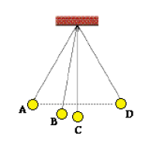
a. force of gravity is the greatest.

b. restoring force is the greatest.

c. speed is the greatest.

d. potential energy is the greatest.

e. kinetic energy is the greatest

f. total mechanical energy is the greatest

3. A pair of trapeze performers at the circus is swinging from ropes attached to a large elevated platform. Suppose that the performers can be treated as a simple pendulum with a length of 16 m. Determine the period for one complete back and forth cycle.

4. Which would have the highest frequency of vibration? Why?
Pendulum A: a 200 g mass attached to a 1.0 m length string
Pendulum B: a 400 g mass attached to a 0.5 m length string

5. Anna wishes to make a simple pendulum that serves as a timing device. She plans to make it such that its period is 1 second. What length must the pendulum have?

6. A pendulum oscillates 24 times per minute in a particular location. If the pendulum is 0.53 m long. What is the acceleration due to gravity there? What length would the pendulum need to have in order to have the same period on earth?

7.

8. A force of 16 N is required to stretch a spring a distance of 40 cm from its rest position. What force is required to stretch the same spring….

a. twice the distance?

b. three times the distance?

c. one half the distance?

8. Perpetually disturbed by the habit of backyard squirrels to raid her bird feeders, Mrs. Ryan decides to use a little physics for better living. His current plot involves equipping her bird feeder with a spring system that stretches and oscillates when the mass of a squirrel lands on the feeder. She wishes to have the highest amplitude of vibration that is possible. Should she use a spring with a large spring constant or small spring constant? Explain.

9. Referring the previous question, if Mrs Ryan wishes to have her bird feeder vibrate with the highest possible frequency, should she use a spring with a large spring constant or a small spring constant? Explain.

10. Use conservation of energy to fill in the blanks in the following diagram.
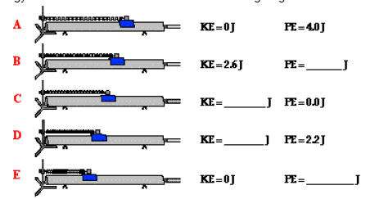

11. Which of the following mass-spring systems will have the highest frequency of vibration?

Case A: A spring with a k = 300 N/m and a mass of 200 g suspended from it

Case B: A spring with a k = 500 N/m and a mass of 100 g suspended from it

12. A 1000 kg car bounces up and down on its springs once every 2 seconds. What is the spring constant for the springs?

