Waves
A wave is...

Ex.
Medium:
Crest:
Trough:
Amplitude (A):
Wavelength (λ):

There are 3 types of mechanical waves:
(1) Transverse

(2) Longitudinal

(3) Surface

Remember that frequency and period are reciprocals, that is:
Ex: An air horn sounds at a frequency of 220 Hz. If the speed of sound in air is 330 m/s what is the wavelength of the sound wave?

Remember that velocity is:
If we look a single wave then:
(1)
(2)
This gives us the Universal Wave Equation:

Ex: The distance between successive crests in a series of water waves is 4.0 m, and the crests travel 8.6 m in 5.0 s. Calculate the frequency of a block of wood bobbing up and down on these water waves.

Ex: Sound travels at approximately 340 m/s, and light travels at 3.0 x 10⁸ m/s. How far away is a lightning strike if the sound of the thunder arrives at a location 2.0 seconds after the lightning is seen?

Ex: Playing middle C on a piano produces a sound with a frequency of 256 Hz. What is the period of the sound wave?

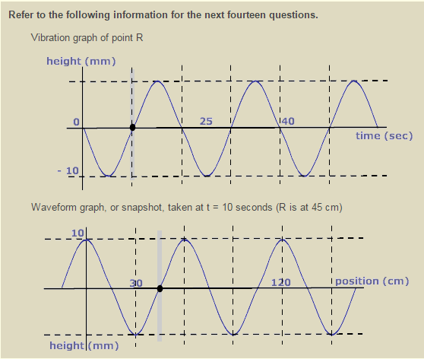
Time graph
Example

Position graph

- What is the amplitude of this wave?
Which graph did you use to find the answer? Time/position/either/both
- What is the wavelength of this wave?
Which graph did you use to find the answer? Time/position/either/both
- What is the period of this wave?
Which graph did you use to find the answer? Time/position/either/both
- What is the frequency of this wave?
Which graph did you use to find the answer? Time/position/either/both
- What is the wave’s speed?
Which graph did you use to find the answer? Time/position/either/both

