Energy Notes

Gravitational potential energy is energy that is ______________ due to _____________
The formula for Gravitational Potential Energy is: It can also be written

The variables stand for: m = _________, g = _________, and h = __________________
Kinetic energy is energy of ________________
The formula for Kinetic Energy is:
The variables stand for: m = ____________, v = __________________ Unit: ______________

The unit for energy is ________________________(symbol = ____).

Example:
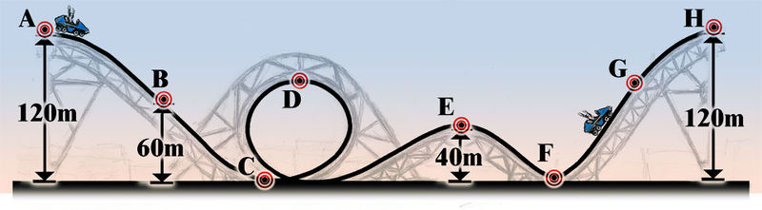
Point A
Mass = 414 kg
h= 120 m
PE = __________________
KE =__________________
Total Energy = ___________

To find energy at other points, use the fact that ______________ ________ ______________ so total energy is always the ____________.

Points B & C
TE = _________________________@B_______________________@C
PE = _________________________@B ______________________@C
KE = _________________________@B ______________________@C
Point D
v = 30.30 m/s
KE = ½mv² = _______________________________________
PE = ____________________
h = _____________________
Points E & F
PE = _____________@E _____________@F
KE = _____________@E _____________@F
v = _____________@E _____________@F
Summary:
On a roller coaster the greatest potential energy is at__________________________________
On a roller coaster the greatest kinetic energy is at____________________________________
What force slows the roller coaster “steals” some energy throughout the ride?______________
What is the effect of this force on the KE (and therefore speed)?___________________________________
The Law of Conservation of Energy states that energy cannot be _____________ or ____________. The total energy in a closed system_____________________________.

List different types of energy and list whether it is potential energy or kinetic energy and give examples of each:
______________ Holds one atom at another atom/ ______________ / Examples: _____________, __________, ________________

______________ Due to number of particles and their motion/ ______________ / Examples: _____________, __________, ________________

______________ Ability to move electrons/ ______________ / Examples: _____________, __________

______________ Energy of vibrations moving through matter/ ______________ / Examples: _____________, __________, ________________

______________ Vibrating electrically charged particles/ ______________ / Examples: _____________, __________, ________________

______________ Energy stored in a spring/ ______________ / Examples: _____________, __________, ________________

_______________Holds protons and neutrons together in the atom’s nucleus/ ______________

Two types of Nuclear Energy:
- Fusion:_________________________________________________________________
_______________________________________________________________________
- Fission:_________________________________________________________________
_______________________________________________________________________

There is no perfect energy conversion or transfer. __________________ always changes some energy into ______________________________ in EVERY energy change.

Mechanical Energy is the energy of an object or a ______________ due to its ____________ or ________________.
List energy that makes up mechanical energy:______________________________
_____________________________________________________________________________
Write the equation for Total Mechanical Energy: _________ + __________ = ____________

Modelling Energy Transfers
A B C

