Measurement Guided Notes Name:_____________________

Scientific Notation
A _______________ method to express ____________________________________ numbers

Scientific Notation is based on powers of the __________________________.

Write the number in scientific notation below and label coefficient and base:

Examples:

Write 1st number (other than zero), then a decimal point and any other numbers other than zero
Count the number of values from the old decimal point to the new one. This is the exponent.
Moved right to left – positive exponent. Moved left to right – negative exponent

123,000,000,000 ____________________ 0.0000000000123 ______________________________

Practice problems:
1.
2.
3.

SI/Metric System
Define: ___________________________________________________________________________________________.
The base unit for mass is __________________(____).
The base unit for volume is _________________(____) or _________________(___).
The base unit for length is ____________________(____).
The base unit for time is _____________________(____).
Metric Conversions
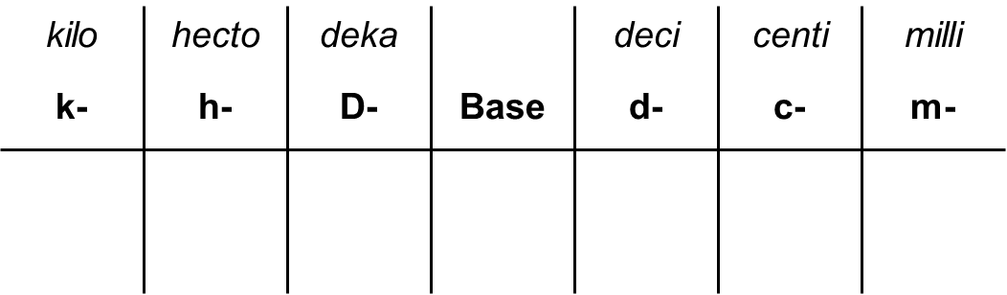
Count how many places you go from the start to what you want. Move the decimal place that many places and in that direction

Example: How many meters are in 0.633 kilometers? Start = ___________________Want = ______________________

Example: How many grams are in 5.678 centigrams? Start = __________________ Want = _________________
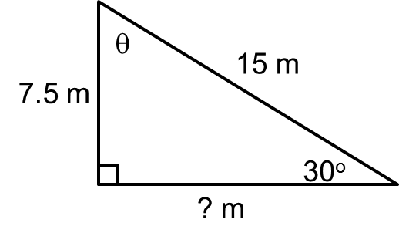
Finding Sides and Angles for Right Triangles
Total degrees in triangle: ______________ Example:
Pythagorean Theorem: ________________

θ = ___________________ ? = _______________________
Rearranging Equations
Solve for x: x + 2 = 4________________________ 2x = 4____________________________

x – 2 = 4________________________ x/2 = 4___________________________

Slope and Area
Area of a square/rectangle = _________________

Area of a triangle = ___________________

Slope = _______________________ (Pick 2 points on line, use formula.)

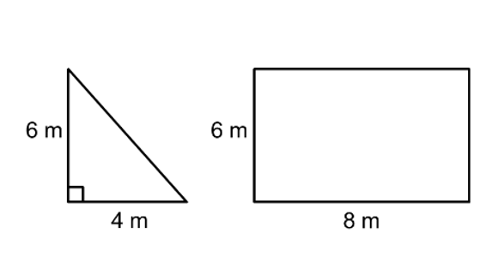
Examples:

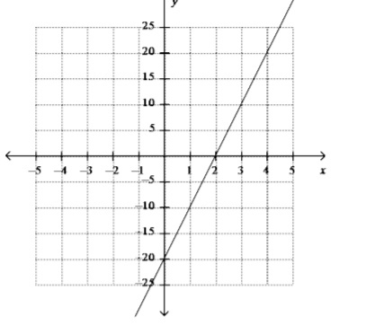

Area = _______________ Area = ___________________ Area = ___________________
Slope = ___________________

