Conservation of Momentum

Law of Conservation of Momentum

If the net external force on a system is _____, then the sum of the momentums of the objects will remain _____________.

Explosions

When an object separates suddenly, as in an explosion, all forces are ____________

Momentum is therefore ___________ in an explosion.

There is an ___________ in __________________ in an explosion. This comes from a potential energy decrease due to chemical combustion.

Ex: Suppose a 5.0-kg projectile launcher shoots a 209 gram projectile at 350 m/s. What is the recoil velocity of the projectile launcher?

Ex: A 75-kg man sits in the back of a 120-kg canoe that is at rest in a still pond. If the man begins to move forward in the canoe at 0.50 m/s relative to the shore, what happens to the canoe?

Ex: A firecracker is placed in a pumpkin which explodes into exactly two pieces. The first piece has a mass of 2.2 kg and flies due east at 26 m/s. The second chunk heads due west at 34 m/s. What was the initial mass of the pumpkin?

Collision Types

____________ collisions

- Also called “hard” collisions

- No _______________ occurs, no __________________ lost

______________collisions

- Deformation occurs, ____________________ is lost

Perfectly Inelastic (________________________)

- Objects stick together and become ______________

- Deformation occurs, _____________________ is lost

Collisions

- When two moving objects make contact with each other, they undergo a ________________.

- _____________________________ is used to analyze all collisions.

- Newton’s Third Law is also useful. It tells us that the force exerted by _________________________in a collision is equal and opposite to the force exerted on _________________

If the goalie stops a 6.5 kg bowling ball traveling at the same velocity in the same amount of time, how much force is required?

Ex: A fish moving at 2 m/s swallows a stationary fish which is 1/3 its mass. What is the velocity of the big fish after dinner?

Ex: An 80-kg roller skating grandma going 6 m/s collides perfectly inelastically with a 40-kg kid at rest. What is their velocity after the collision? How much kinetic energy is lost?

Ex: A car with a mass of 950 kg and a speed of 16 m/s to the east approaches an intersection. A 1300-kg minivan traveling north at 21 m/s approaches the same intersection. The vehicles collide and stick together. What is the resulting velocity of the vehicles after the collision?

2-D Collisions

Momentum in the x-direction is conserved.

ΣPx (before) = ΣPx (after)

Momentum in the y-direction is conserved.

ΣPy (before) = ΣPy (after)

Treat x and y coordinates independently.

Break momentum into _____________

Work a problem in the _____ ___________

Work a problem in the ____ ____________

Put x and y ______________ back together

Ex: Two carts of equal mass move towards each other with identical speeds of 0.3 m/s. After colliding, the carts bounce off each other, each regaining 0.30 m/s of speed, but now moving in the opposite direction. Is this an elastic collision?

Ex: Calculate velocity of 8-kg ball after the collision.

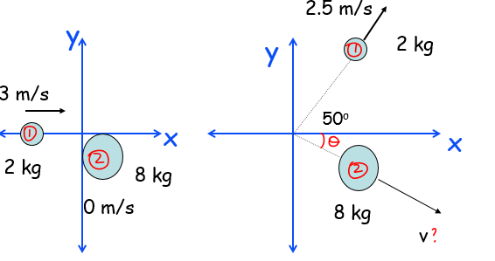

Ballistics Pendulum

A ballistics pendulum was used in munitions factory to test the velocity of the bullets manufactured. A bullet is fired into a block of wood hanging on a string. The height to which the pendulum swings is measured and from this the initial velocity of the bullet can be measured.



Ex: A bullet with mass of 0.05 kg is fired into a ballistics pendulum with mass 3 kg. It swings to a height of 0.32 m. What is the velocity of the bullet?