Standing Waves

**Reflection**

Occurs when a wave strikes a medium boundary and __________ ________ into original medium

Completely reflected waves have the same ________ and ________ as the original wave

**Interference**

When two waves _________, they don’t bounce or stick like objects do, they ___________

This means they form ______ wave for a moment and then continue on ___________

The total amplitude of the waves is equal to…

Two waves with the same frequency and opposite phase.

**Destructive Interference:**

Two waves with the same frequency and phase. **Constructive Interference:**

Waves can have constructive and destructive interference at ____________________ _______________________

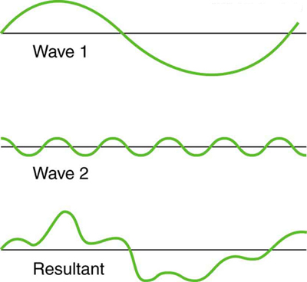

**Standing Waves**

* When a wave hits a fixed boundary it will _____________ and _____________ its amplitude.
* If a series of waves are sent along a string the reflected pulse will ________________ with the next pulse
* If the waves are sent at just the right frequency we will create a _______________ ______________.
* Areas of complete destructive interference have ____ _______________ and are called __________
* Areas of complete constructive interference have _____ ______________ and are called __________

**Harmonics**

- Musical instruments vibrate in such a way that a ___________________ pattern results

- These patterns are only created within the instrument at specific _____________ of vibration; these frequencies are known as harmonic frequencies, or merely **________________**

- The first frequency is called the ______________ _____________ – it determines the ___________

- The higher harmonics are called _________________________

**Harmonics – closed at one end, open at one end**

- Pipes that are open at one end have an antinode at one end and a node at the other.

- Each sound you hear will occur when an ***__________***appears at the top of the pipe.

- You get your first sound or

encounter your first antinode

when the length of the actual

pipe is equal to a _________

of a wavelength.

You have a _______ at the 2nd

harmonic position, therefore

_____ sound is heard

You have an _____________ at the 3rd harmonic position, therefore __________ is produced.

Sounds in pipes with one open end are produced only at ______ harmonics

- Sounds in open or fixed end pipes are produced at _______ harmonics

**Harmonics – 2 open ends or 2 fixed ends**

- Sounds are heard for 2 fixed ends when a ______ is at the end, they are heard in 2 open ends when an _____________ is at the end.

- In both cases, this first occurs at _________ of a wavelength. This is called the fundamental frequency.

2 open ends 2 fixed ends

1) The Sun is 1.50x108 km from Earth. How long does it take for the light from the Sun to reach us?

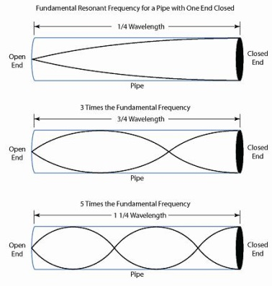

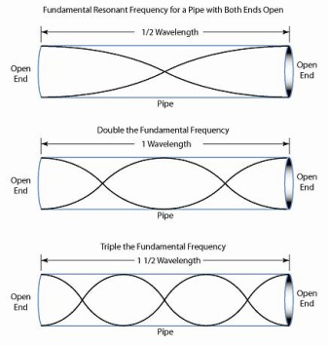

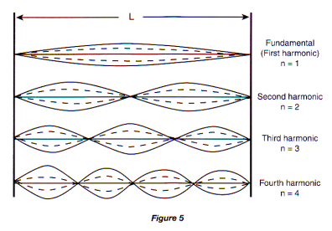

**Example**

- How long do you need to make an organ pipe (open at both ends) that produces a fundamental frequency of middle C (256 Hz)? The speed of the sound in air is 340 m/s.

b. What is the wavelength and frequency of the 2nd harmonic? Draw the standing wave

**Example**

The windpipe of a typical whooping crane is about 1.525-m long. What is the lowest resonant frequency of this pipe assuming it is a pipe closed at one end? Assume the speed of sound is 353 m/s