

1. Two pulses on a cord at time *t* = 0 are moving toward each other; the speed each pulse is 2 cm/s.
2. Sketch the shape of the cord at time *t* = 3 s.

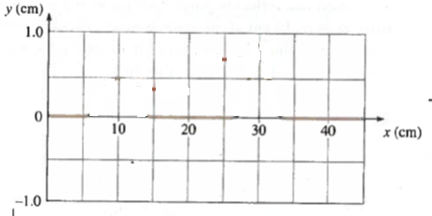

1. Sketch the shape of the cord at *t* = 5 s.



1. Sketch the shape of the cord at *t* = 12 s.



1. Bats and dolphins both use ultrasonic sound waves to identify obstacles and prey. They can detect the location of any object that reflects a significant fraction of the sound energy. This means that, they can detect objects approximately as small as the wavelength of the ultrasonic pulse.

Bats emit ultrasonic waves with frequencies as high as 100 kHz. Dolphins emit ultrasonic waves with frequency as high as 250 kHz.

1. Calculate the wavelength of the bat’s sound waves. Justify the reasonability of your answer.
2. Who can detect smaller objects, bats or dolphins? And, approximately how many times smaller?

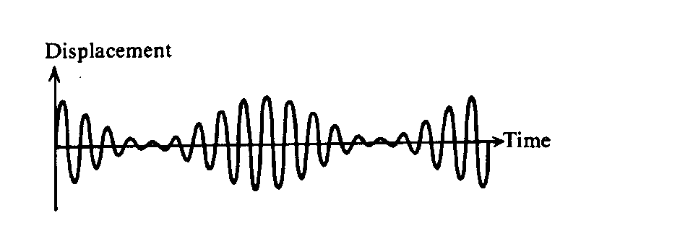

3. Two sinusoidal functions of time are combined to obtain the result shown in the figure above. Which of the following can best be explained by using this figure?

o Beats

o Simple harmonic motion

o Refraction

o Diffraction

o Doppler effect

Justify your answer by explaining not only why the correct answer is correct, but why at least two of the other answers cannot be correct.