3. Kinematics – Vertical Motion (Freefall) Key points

Freefall means the object’s ___________ (____________________) is the __________ force acting on it

Acceleration due to gravity
__________ toward the ______________
This means that an object’s speed _____________ by _____________ every _____________

Symmetry in freefall
- The up and down trip of an object in freefall is absolutely _______________
- The coin spends ________ of the time rising and ________ falling.
- The speed when the coin returns to the hand _________ the speed with which the coin left the hand.
- The coin undergoes an acceleration of ___________ during both halves of the trip.
- Velocity at top of motion = __________

Air resistance will be ignored in calculations but may be asked about qualitatively

Examples

1. A stone is dropped at rest from the top of a cliff. It is observed to hit the ground 5.8s later. How high is the cliff ?

2. You drop a ball from 120m high cliff.
a) how long is the ball in the air ?

b) What is the ball’s velocity at impact ?

c) How long does it take to reach the halfway point ?

d) What is the velocity when the ball has fallen halfway to the ground ?

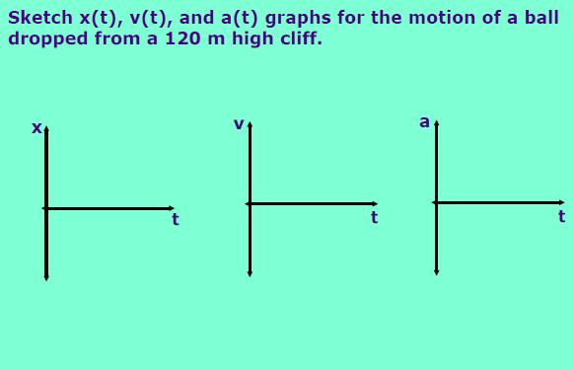

3. You throw a ball straight up into the air. It leaves your hand with a velocity of 30 m/s, and you catch it a moment later.
a) How long is the ball in the air?

b) How high above your hand will the ball rise?

c) What is the velocity of the ball when you catch it?

d) What is the acceleration of the ball at its highest point?

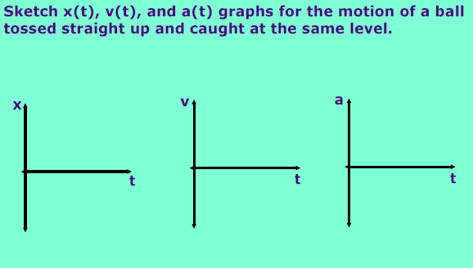

4. A helicopter is ascending vertically with a speed of 5.00 m/s. At a height of 105 m above the ground, a package is dropped from the window. How long does it take for the package to hit the ground?

5. A mango is dropped from a height of y.
If dropped from 2y, what would happen to time in the air?

